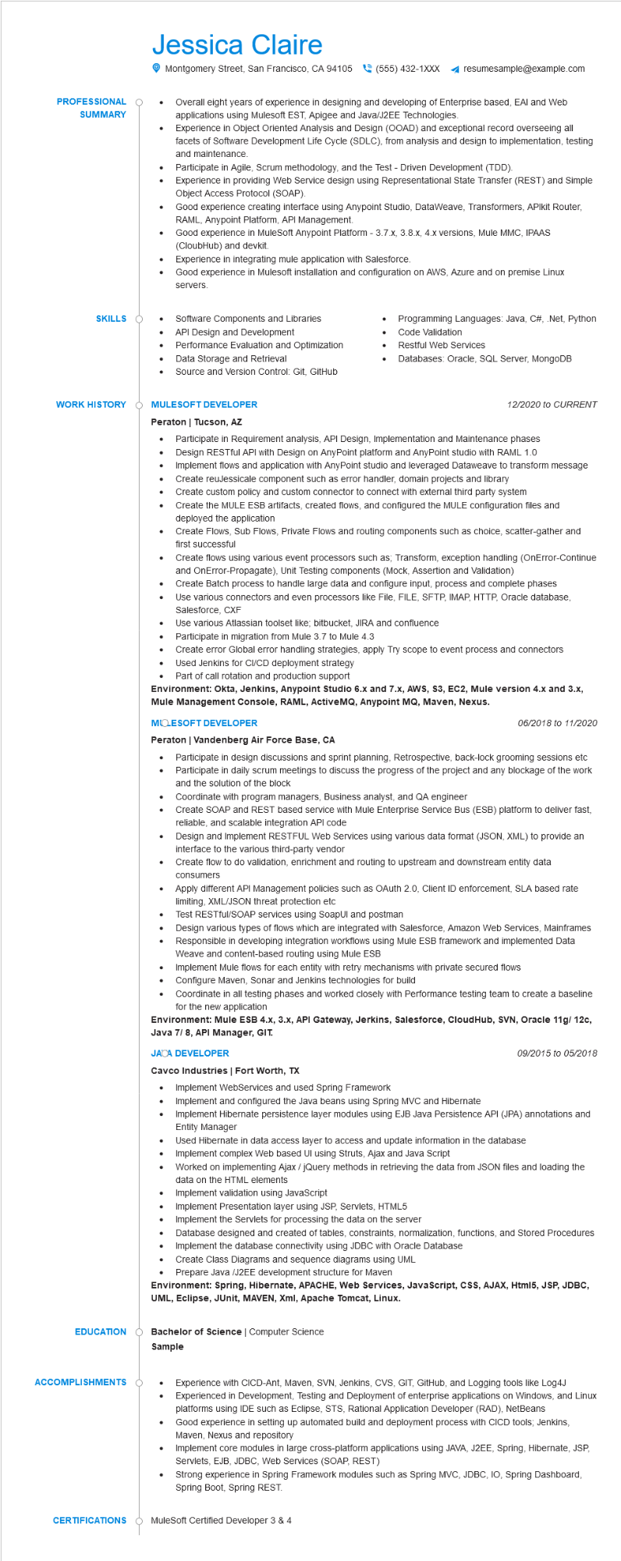
PROFESSIONAL
SUMMARY
Jessica Claire
•
•
Montgomery Street, San Francisco, CA 94105 (555) 432-1XXX
resumesample@example.com
Overall eight years of experience in designing and developing of Enterprise based, EAI and Web applications using Mulesoft EST, Apigee and Java/J2EE Technologies.
Experience in Object Oriented Analysis and Design (OOAD) and exceptional record overseeing all facets of Software Development Life Cycle (SDLC), from analysis and design to implementation, testing and maintenance.
Participate in Agile, Scrum methodology, and the Test - Driven Development (TDD).
Experience in providing Web Service design using Representational State Transfer (REST) and Simple Object Access Protocol (SOAP).
Good experience creating interface using Anypoint Studio, DataWeave, Transformers, APlkit Router, RAML, Anypoint Platform, API Management.
Good experience in MuleSoft Anypoint Platform - 3.7.x, 3.8.x, 4.x versions, Mule MMC, IPAAS (CloubHub) and devkit.
Experience in integrating mule application with Salesforce.
Good experience in Mulesoft installation and configuration on AWS, Azure and on premise Linux servers.
SKILLS
•
•
Software Components and Libraries
API Design and Development
Performance Evaluation and Optimization
•
Data Storage and Retrieval
•
Source and Version Control: Git, GitHub
WORK HISTORY
Ó MULESOFT DEVELOPER
Programming Languages: Java, C#, .Net, Python Code Validation
Restful Web Services
Databases: Oracle, SQL Server, MongoDB
12/2020 to CURRENT
Peraton | Tucson, AZ
•
Participate in Requirement analysis, API Design, Implementation and Maintenance phases Design RESTful API with Design on AnyPoint platform and AnyPoint studio with RAML 1.0 Implement flows and application with AnyPoint studio and leveraged Dataweave to transform message Create reuJessicale component such as error handler, domain projects and library Create custom policy and custom connector to connect with external third party system
• Create the MULE ESB artifacts, created flows, and configured the MULE configuration files and deployed the application
•
·
•
Create Flows, Sub Flows, Private Flows and routing components such as choice, scatter-gather and first successful
Create flows using various event processors such as; Transform, exception handling (OnError-Continue and OnError-Propagate), Unit Testing components (Mock, Assertion and Validation)
Create Batch process to handle large data and configure input, process and complete phases
Use various connectors and even processors like File, FILE, SFTP, IMAP, HTTP, Oracle database, Salesforce, CXF
Use various Atlassian toolset like; bitbucket, JIRA and confluence
Participate in migration from Mule 3.7 to Mule 4.3
Create error Global error handling strategies, apply Try scope to event process and connectors
· Used Jenkins for CI/CD deployment strategy
Part of call rotation and production support
Environment: Okta, Jenkins, Anypoint Studio 6.x and 7.x, AWS, S3, EC2, Mule version 4.x and 3.x, Mule Management Console, RAML, ActiveMQ, Anypoint MQ, Maven, Nexus.
MOLESOFT DEVELOPER
Peraton | Vandenberg Air Force Base, CA
06/2018 to 11/2020
• Participate in design discussions and sprint planning, Retrospective, back-lock grooming sessions etc Participate in daily scrum meetings to discuss the progress of the project and any blockage of the work and the solution of the block
·
Coordinate with program managers, Business analyst, and QA engineer
Create SOAP and REST based service with Mule Enterprise Service Bus (ESB) platform to deliver fast, reliable, and scalable integration API code
Design and Implement RESTFUL Web Services using various data format (JSON, XML) to provide an interface to the various third-party vendor
Create flow to do validation, enrichment and routing to upstream and downstream entity data consumers
Apply different API Management policies such as OAuth 2.0, Client ID enforcement, SLA based rate limiting, XML/JSON threat protection etc
Test RESTful/SOAP services using SoapUI and postman
Design various types of flows which are integrated with Salesforce, Amazon Web Services, Mainframes Responsible in developing integration workflows using Mule ESB framework and implemented Data Weave and content-based routing using Mule ESB
Implement Mule flows for each entity with retry mechanisms with private secured flows
Configure Maven, Sonar and Jenkins technologies for build
Coordinate in all testing phases and worked closely with Performance testing team to create baseline for the new application
Environment: Mule ESB 4.x, 3.x, API Gateway, Jerkins, Salesforce, CloudHub, SVN, Oracle 11g/ 12c, Java 7/ 8, API Manager, GIT.
JACA DEVELOPER
Cavco Industries | Fort Worth, TX
•
Implement WebServices and used Spring Framework
Implement and configured the Java beans using Spring MVC and Hibernate
09/2015 to 05/2018
Implement Hibernate persistence layer modules using EJB Java Persistence API (JPA) annotations and Entity Manager
Used Hibernate in data access layer to access and update information in the database
Implement complex Web based Ul using Struts, Ajax and Java Script
• Worked on implementing Ajax / jQuery methods in retrieving the data from JSON files and loading the data on the HTML elements
Implement validation using JavaScript
•
Implement Presentation layer using JSP, Servlets, HTML5
Implement the Servlets for processing the data on the server
Database designed and created of tables, constraints, normalization, functions, and Stored Procedures
Implement the database connectivity using JDBC with Oracle Database
•
Create Class Diagrams and sequence diagrams using UML
• Prepare Java/J2EE development structure for Maven
Environment: Spring, Hibernate, APACHE, Web Services, JavaScript, CSS, AJAX, Html5, JSP, JDBC, UML, Eclipse, JUnit, MAVEN, Xml, Apache Tomcat, Linux.
EDUCATION
Bachelor of Science | Computer Science Sample
ACCOMPLISHMENTS
•
Experience with CICD-Ant, Maven, SVN, Jenkins, CVS, GIT, GitHub, and Logging tools like Log4J Experienced in Development, Testing and Deployment of enterprise applications on Windows, and Linux platforms using IDE such as Eclipse, STS, Rational Application Developer (RAD), NetBeans Good experience in setting up automated build and deployment process with CICD tools; Jenkins, Maven, Nexus and repository
•
Implement core modules in large cross-platform applications using JAVA, J2EE, Spring, Hibernate, JSP, Servlets, EJB, JDBC, Web Services (SOAP, REST)
•
Strong experience in Spring Framework modules such as Spring MVC, JDBC, IO, Spring Dashboard, Spring Boot, Spring REST.
CERTIFICATIONS MuleSoft Certified Developer 3 & 4

